Technical Approach Note & Proprietary Platform Architecture
AI-Assisted Multilingual Translation & Dubbing of e-Learning Courses
iGOT Karmayogi Platform — Karmayogi Bharat (SPV)
RFB No. IN-KBL-543730-NC-RFB | Submitted by: Novac Technology Solutions Pvt. Ltd. (Immerz Division)

1. Executive Summary
Novac Technology Solutions proposes to deliver the entire scope of translation and dubbing of iGOT Karmayogi e-Learning courses on the MigotoAI Translation Engine, Novac’s proprietary, India-hosted, sovereign AI localisation engine built and operated by the Immerz Division. The Engine is not an integration wrapper over public translation APIs. It is a purpose-built, closed-loop media localisation pipeline running Novac-owned, domain fine-tuned and quantized neural models for Indic ASR, machine translation, and neural text-to-speech, orchestrated by an agentic workflow layer with human linguist checkpoints at every quality gate.
The platform is engineered specifically against the operational shape of this ToR: monthly batches of 50–125 output hours, 11 mandatory target languages with 11 additional scheduled languages on demand, a 98% linguistic accuracy SLA, a 20% output-duration constraint, a 5-day defect correction window, and mandatory data residency within India. Every architectural decision below is traceable to one of these constraints.
Key differentiators aligned to Table A (S.No.5) and Technical Scoring (S.No.4):
- Proprietary platform and Novac-owned model weights — no dependence on third-party hosted LLM/MT APIs; no KB content ever leaves the India-resident boundary.
- Domain fine-tuned models on Indian governance, administrative, and public-policy corpora, so that administrative context is retained rather than literally transliterated.
- Quantized model serving (INT8 / INT4 / GGUF-class weight compression) enabling high-throughput parallel inference across 11+ languages on a modest sovereign GPU footprint — this is what makes 125 output-hours/month economically and schedule-feasible.
- Segment-level Translation Memory, enforced Glossary and Do-Not-Translate (DNT) registries, giving deterministic terminology consistency across all 61 courses and all languages.
- Duration-aware TTS with prosody and timing control to hold voiceover within the 20% expansion ceiling and in sync with on-screen text.
- Full audit trail, versioning and traceability from source asset to CBP-portal-accepted deliverable, supporting the joint-accountability regime at Clause 5.1(D).
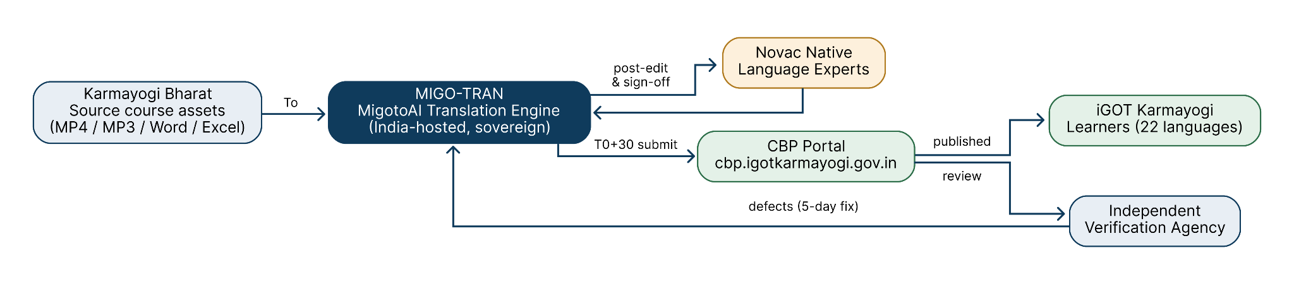
Figure 1 — Solution Context: how the MigotoAI Translation Engine sits between Karmayogi Bharat, the Verification Agency and the CBP portal

2. Understanding of the Requirement — Engineering Interpretation
ToR Requirement | Engineering Implication | Platform Response
On-demand translation of existing courses using a robust AI model | Batch + on-demand ingestion; unpredictable course/language allocation per month | Queue-driven job orchestration with per-language worker pools; horizontal scaling on demand
11 mandatory + 11 additional scheduled languages | Low-resource languages (Bodo, Santhali, Dogri, Sindhi) have scarce parallel data | Two-tier model strategy: high-resource fine-tuned NMT; low-resource pivot + LoRA adapters + heavier human post-editing weighting
No mere transliteration; retain administrative context | Generic MT fails on Indian governance register | Domain-adapted fine-tuning on administrative/policy corpora + enforced glossary + DNT registry
Voiceover natural, Indian neutral accent, in sync with on-screen text | Indic renditions expand 15–30% over English | Duration-constrained TTS: compression ratio control, adaptive pause redistribution, segment-level time-alignment
Exclusions: PDFs, dignitary speeches, YouTube-origin video, already-translated assets | Automated scope filtering needed before any compute is spent | Pre-flight Scope Classifier with speaker identification, language detection and exclusion rule engine; auditable exclusion report per course
98% linguistic accuracy; consistency of terminology | Quality must be measurable, not asserted | Multi-gate QA with automated quality-estimation scoring + native linguist sign-off + MQM-style error typology reporting
95% monthly delivery; 5-day correction; T0+70 day closure | Throughput and traceability are the binding constraints | Capacity planning engine, SLA clock instrumentation, defect-tracker with round-trip versioning
GoI data security, confidentiality, data residency; sovereign AI preference | No public cloud AI API calls permitted | India-hosted deployment, Novac-owned weights, encrypted at rest and in transit, RBAC, no telemetry egress

3. MigotoAI Translation Engine — Proprietary Platform Architecture

3.1 Architectural Principles
- Sovereign by construction — all model weights, inference runtime, storage and orchestration operate inside a Novac-controlled, India-resident environment (MeitY-empanelled cloud or KB-designated VPC/on-premise).
- Deterministic where it matters — terminology, DNT, numerals, statutory names and scheme names are resolved by rule and registry, not by model sampling.
- Human-in-the-loop by design — AI is used for scale; native linguists own the acceptance decision at every gate.
- Idempotent and re-runnable — any stage can be replayed for a single segment without reprocessing the whole course, which is what makes the 5-day correction SLA achievable.
- Traceable — every delivered second of audio maps back to a source segment, a model version, a glossary version, and a named human reviewer.

3.2 Layered Architecture
The MigotoAI Translation Engine is organised as ten functional layers. Each layer has a single responsibility and a defined hand-off, so work can be re-run at one layer without disturbing the rest — this is what makes the 5-day defect-correction SLA practical.
Layer | Components
L1 — Ingestion & Asset Management | Secure intake portal (SFTP/HTTPS), media validator, checksum and provenance registry, MP4/MP3/DOCX/XLSX parsers, course package decomposer
L2 — Pre-Flight Intelligence | Scope Classifier (exclusion rules), speaker diarization & dignitary voice detection, source language identification, existing-translation detection, shot/scene and on-screen-text detection (OCR)
L3 — Speech & Text Extraction | Fine-tuned Indic ASR with timestamped segmentation, source separation (speech vs music-and-effects stems), forced alignment, transcript normalisation
L4 — Linguistic Core | Fine-tuned + quantized NMT engines (per language pair), Glossary Service, DNT Registry, Translation Memory (segment + fuzzy match), Named-Entity & Numeral Normaliser, Register/Style controller
L5 — Quality Estimation | Automated QE scoring (COMET-class reference-free estimation), terminology-compliance checker, back-translation semantic-drift detector, profanity/objectionable-content filter, length-ratio guard
L6 — Human Post-Editing Workbench | Browser-based CAT-style editor: bilingual segment view, in-context video playback, TM/glossary suggestions, change-tracking, reviewer attribution, approval workflow
L7 — Voice Synthesis & Dubbing | Multi-speaker neural TTS (Indic, neutral accent), optional consented voice cloning, duration-constrained synthesis, prosody & emphasis control, SSML pipeline
L8 — Media Assembly | Timeline re-alignment, M&E stem re-mix and level normalisation (EBU R128), on-screen-text sync verification, MP4/MP3 encoding to KB technical standards
L9 — QA & Certification | Automated technical QC (codec, bitrate, loudness, sync drift, silence gaps), linguist certification workflow, self-certification pack generation
L10 — Delivery & Governance | CBP portal submission module, defect tracker with 5-day SLA clock, batch reporting, SLA and capacity dashboards, consolidated completion and glossary reports
Cross-cutting | the agentic workflow layer agentic orchestration, identity & RBAC, encryption (AES-256 at rest, TLS 1.3 in transit), immutable audit log, versioned artefact store, observability & alerting

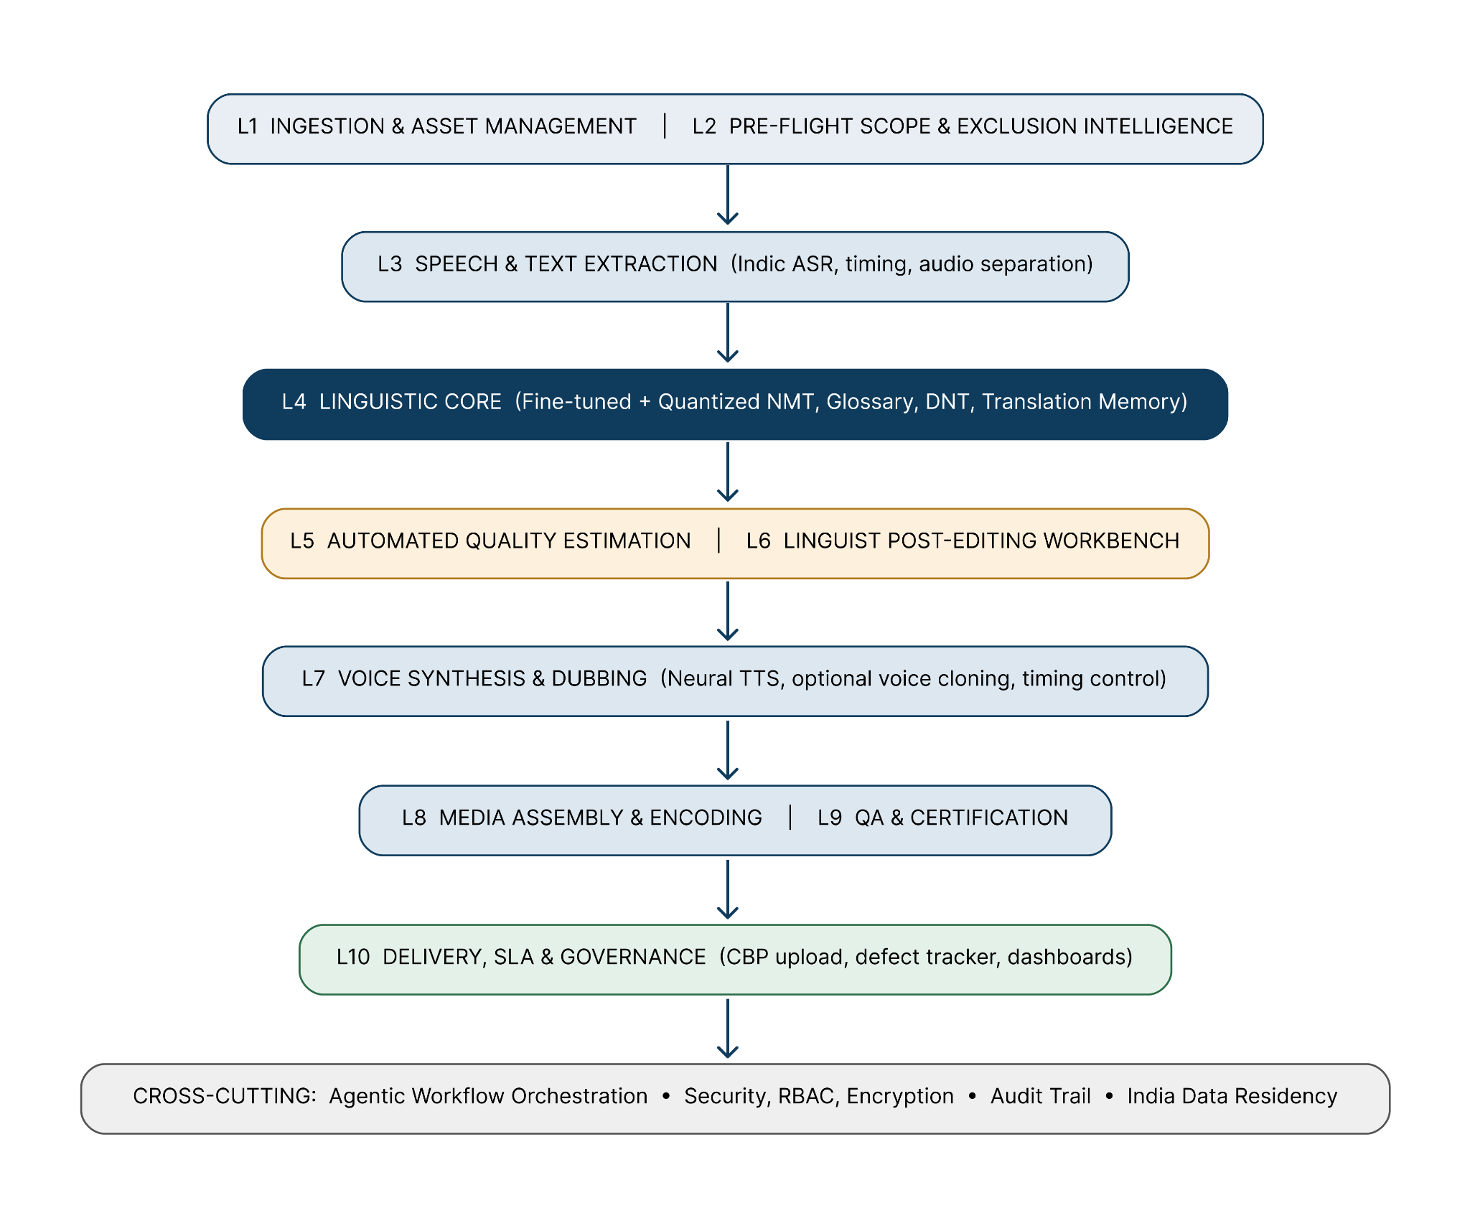
Figure 2 — MigotoAI Translation Engine — Layered Platform Architecture

3.3 Model Strategy — Fine-Tuned and Quantized
The solution explicitly uses fine-tuned and quantized models. This is a deliberate engineering position, not a cost measure.

3.3.1 Fine-Tuning
- Domain adaptation: base Indic ASR/NMT/TTS checkpoints are further trained on a curated corpus of Indian administrative, governance, public-policy, civil-service training and Mission Karmayogi-adjacent material, so that register, honorifics, scheme names and administrative idiom are handled natively.
- Parameter-efficient fine-tuning (LoRA / QLoRA adapters) per language and per domain, so a new language or a KB-specific terminology shift can be onboarded in days rather than retraining a full model.
- Continuous improvement loop: every human post-edit is captured as a supervised training pair and folded back into the adapter refresh cycle, so accuracy improves monotonically across the 12-month contract (subject to KB’s data-use consent).
- Speaker-adapted TTS fine-tuning for a consistent, indigenous, neutral-accent narrator voice per language, ensuring a single recognisable learning voice across all 61 courses.

3.3.2 Quantization
- Post-training and quantization-aware compression of NMT, ASR and TTS weights to INT8 / INT4 (GGUF/AWQ-class) representations, with per-language accuracy regression gates before any quantized model is promoted to production.
- Effect: 2.5–4x inference throughput uplift and ~60–75% reduction in GPU memory footprint, allowing many language pipelines to be served concurrently on the same sovereign GPU node.
- Operational consequence: the 125 output-hour peak month is met by parallel language workers rather than by serial processing — directly de-risking the 95% monthly delivery SLA.
- Quality guardrail: quantized models are accepted into production only if BLEU/chrF and QE scores stay within a pre-defined tolerance of the full-precision baseline; otherwise the full-precision model is retained for that language.
- Edge/air-gapped capability: quantized footprints permit deployment inside a KB-controlled or air-gapped environment should KB require processing within its own boundary.
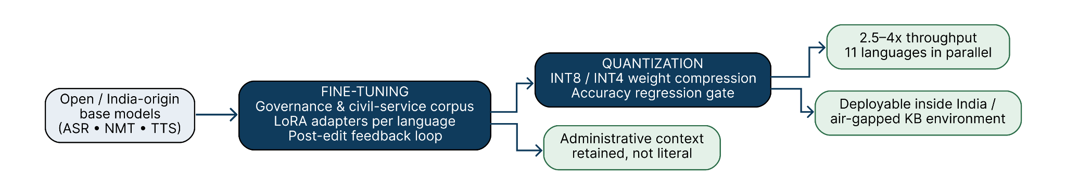
Figure 3 — Model Strategy: fine-tuning gives accuracy in the Indian administrative register; quantization gives the throughput needed for 125-hour peak months

3.4 End-to-End Processing Pipeline
The pipeline alternates machine stages with human checkpoints. AI is used for scale and consistency; a native language expert always owns the acceptance decision.
# | Stage | Automated / Human | Output
1 | Asset intake, validation, provenance registration | Automated | Verified course package, T0 timestamp
2 | Scope classification & exclusion filtering | Automated + linguist confirm | Exclusion report; translatable asset list
3 | Source separation and timestamped ASR transcription | Automated | Segment-level transcript with timecodes; M&E stem
4 | Transcript verification | Human (native) | Approved source transcript
5 | TM / glossary / DNT resolution and MT inference | Automated (fine-tuned + quantized NMT) | Draft target-language segments
6 | Automated quality estimation & terminology compliance check | Automated | QE score, flagged segments
7 | Contextual post-editing | Human (native linguist) | Publication-grade target text
8 | Linguistic review & sign-off | Human (senior language lead) | Certified translation
9 | Duration-constrained neural TTS / voice cloning | Automated | Voiceover audio per segment
10 | Voice QA — pronunciation, prosody, naturalness | Human (native) | Approved voice track
11 | Timeline assembly, M&E remix, sync verification | Automated + human spot-check | Dubbed MP4 / MP3
12 | Technical QC (codec, loudness, drift, format) | Automated | QC pass certificate
13 | Metadata, quiz and assessment translation & formatting | Automated + human | Word/Excel deliverables
14 | Internal QA certification & submission pack | Human | Self-certification, submission report
15 | CBP portal upload; verification-agency round trip | Automated + human | Accepted course

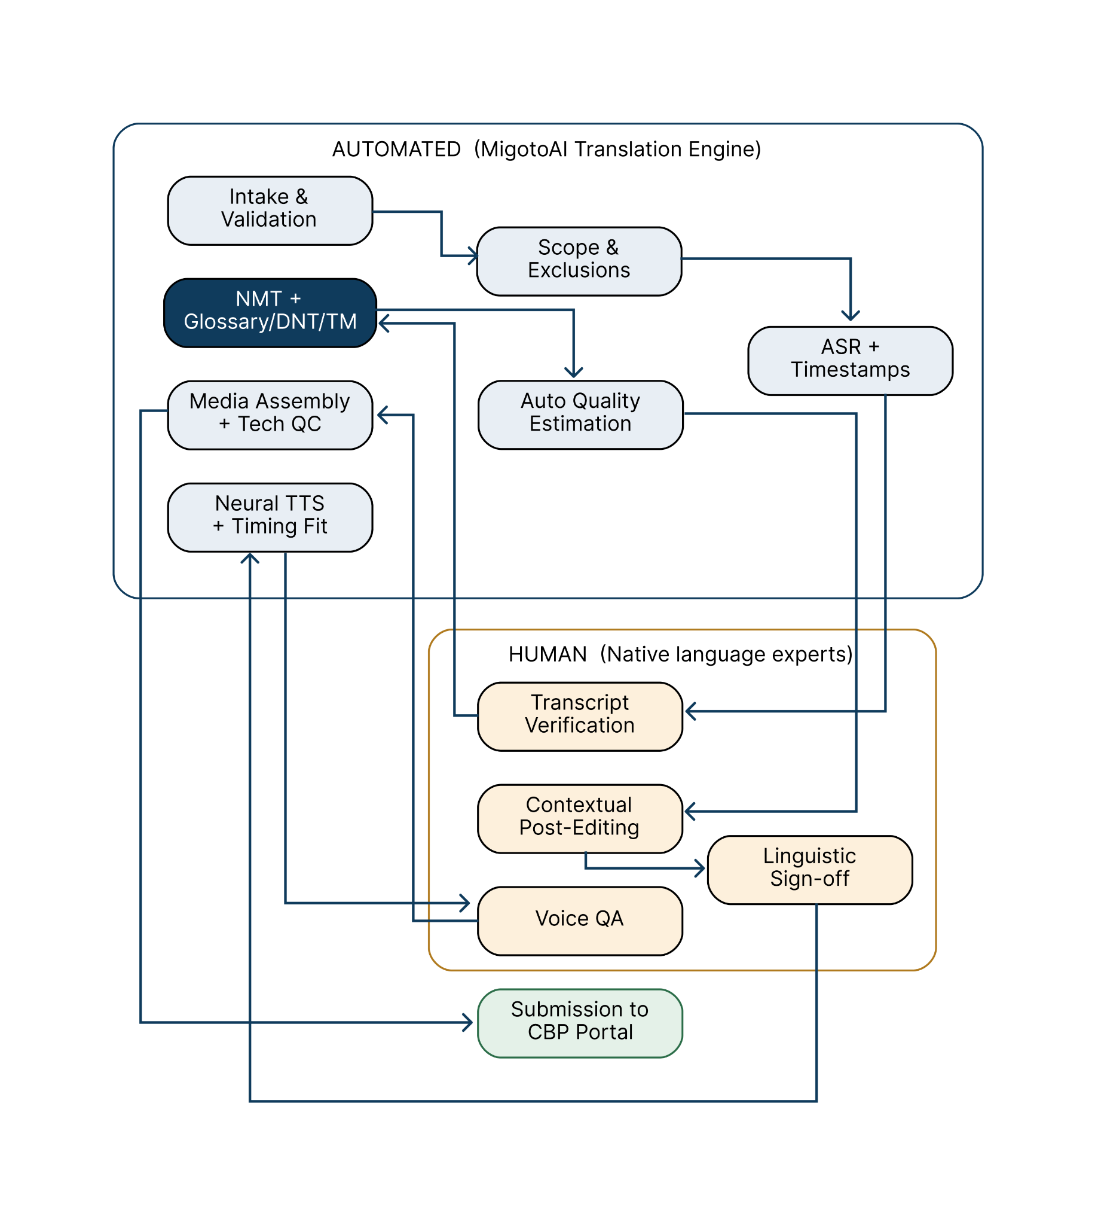
Figure 4 — End-to-End Processing Pipeline (automated stages and human checkpoints)

4. Functional Components — Detailed Specification
FC-01 Secure Ingestion & Asset Registry
Authenticated intake of MP4/MP3/DOCX/XLSX; SHA-256 checksum, immutable provenance record, T0 stamping per batch, media probe validation (codec, duration, channels, bitrate), automatic rejection and KB notification for corrupt or non-conforming assets.
FC-02 Scope & Exclusion Classifier
Rule + model driven detection of: PDF assets, dignitary speeches (speaker recognition against a curated reference set), YouTube-origin media without source file, and assets already present in the target language. Produces an auditable per-course exclusion manifest for KB reference.
FC-03 Indic ASR & Segmentation Engine
Fine-tuned, quantized multilingual ASR producing word-level timestamps; VAD-based segmentation aligned to natural pause boundaries; speaker diarization; code-mixed English-Indic handling; forced alignment for precise timing.
FC-04 Source Separation & Audio Preservation
Separation of narration from background music and effects so that the original soundscape is preserved under the new voiceover; loudness-normalised remix to broadcast standard.
FC-05 Neural Machine Translation Core
Per-language-pair fine-tuned and quantized NMT with context-window carry-over across adjacent segments (document-level context) to preserve discourse coherence; register control for formal administrative Indian usage; configurable literal-vs-idiomatic bias.
FC-06 Glossary & Terminology Management Service
Central, versioned glossary of standardised administrative and course-domain terms per language, enforced at inference through constrained decoding and validated post-hoc. Supports KB-supplied glossary import, vendor-proposed term approval workflow, and produces the end-of-contract Glossary of Standardized Translated Terms.
FC-07 Do-Not-Translate (DNT) Registry
Protected-entity list covering trademarks, content-provider names, scheme and programme names, statutory titles, acronyms, URLs, numerals and codes. Entities are masked before inference and restored after, guaranteeing zero corruption of protected strings.
FC-08 Translation Memory (TM)
Segment-level exact and fuzzy-match memory scoped per language and per content provider. Cross-course reuse enforces consistency across all 61 courses and materially accelerates later batches, protecting the 125-hour peak months.
FC-09 Automated Quality Estimation
Reference-free quality scoring per segment, terminology-compliance verification, back-translation semantic-drift detection, length-ratio guard against the 20% duration rule, and an objectionable-content filter screening for hate speech, abuse, violence, profanity and vulgarity as required by the ToR.
FC-10 Linguist Post-Editing Workbench
Purpose-built browser workbench: bilingual segment grid, synchronised video preview, TM and glossary suggestion pane, inline QE flags, comment threads, tracked changes, reviewer attribution and role-based approval. Every edit is captured for the model improvement loop.
FC-11 Neural Text-to-Speech & Dubbing Engine
Multi-speaker Indic TTS in a neutral Indian accent with fine-tuned speaker embeddings; SSML-driven control of pause, emphasis, rate and pitch; duration-constrained synthesis that fits each segment into its source time window; optional voice cloning invoked only against documented consent.
FC-12 Timing & Sync Controller
Per-segment time-budget solver combining speech-rate modulation, intelligent pause redistribution and silence reclamation to align the dubbed track with on-screen text; automatic drift detection and reporting where a segment cannot be fitted without exceeding tolerance.
FC-13 Media Assembly & Encoding
Deterministic re-assembly of the localised timeline, remix with preserved M&E stem, loudness normalisation, and encoding to KB-specified MP4/MP3 targets with codec and container conformance checks.
FC-14 Document & Assessment Localisation
Structure-preserving translation of reflection quizzes, final assessments and course metadata in Word/Excel, retaining question numbering, option order, answer keys, scoring logic and formatting; distractor plausibility is linguist-reviewed so that assessment validity survives translation.
FC-15 QA Certification & Reporting Engine
Automated technical QC suite plus human certification workflow; auto-generates the Language Quality Assurance Certification, Month-wise Submission Report, and Correction & Closure Report required at ToR Clause 4.5.
FC-16 CBP Portal Delivery Module
Packaging to CBP portal conventions and submission (API-driven where exposed, assisted-manual otherwise), with submission receipts, per-course status tracking and re-upload versioning after correction.
FC-17 Defect & SLA Management
Verification-agency feedback capture, defect classification by severity, routing to the responsible linguist, 5-day correction clock with escalation, re-submission tracking, and evidence pack generation supporting the joint-accountability clause.
FC-18 Capacity & Delivery Command Centre
Live dashboard of hours in progress by language and stage, linguist and voice-artist utilisation, forecast versus committed monthly hours, burn-down against T0+30 and T0+70 milestones, and early-warning alerts before an SLA threshold is breached.
FC-19 Agentic Workflow Orchestration Layer
The agentic workflow layer schedules, retries, parallelises and gates every stage above; enforces that no artefact advances without its required human approval; supports selective re-run at segment granularity.
FC-20 Security, Audit & Compliance Layer
Identity and RBAC with least privilege, AES-256 encryption at rest, TLS 1.3 in transit, immutable audit logging of every access and transformation, data-residency enforcement, no outbound model/telemetry egress, configurable retention and certified destruction at contract close.

5. Quality Assurance Framework
Quality is enforced as a sequence of gates. No course advances to the next stage until the current gate is cleared and attributed to a named owner.
Gate | Check | Owner | Exit Criterion
G0 | Source asset integrity and scope classification | Platform + Delivery Lead | Exclusion manifest approved
G1 | Source transcript fidelity | Native linguist | 100% transcript sign-off
G2 | Automated QE and terminology compliance | Platform | QE threshold met; zero glossary/DNT violations
G3 | Contextual post-editing | Native linguist | Publication-grade text
G4 | Independent linguistic review | Senior language lead (not the post-editor) | ≥ 98% linguistic accuracy certified
G5 | Voice naturalness and pronunciation | Native linguist / voice QA | Approved voice track
G6 | Technical QC — sync, loudness, codec, duration ratio | Platform | QC pass; duration within tolerance
G7 | Internal QA certification | QA Lead | Self-certification pack signed
G8 | Verification-agency review and closure | Verification Agency / KB | Formal acceptance on CBP portal

Figure 5 — Nine-Gate Quality Assurance Framework

Accuracy measurement: Novac proposes an MQM-style error typology (critical / major / minor) applied to a statistically valid sample per course per language, reported transparently to KB and the Verification Agency, so that the 98% accuracy SLA is adjudicated on evidence rather than opinion.

6. Delivery Model, Throughput & SLA Assurance
- Monthly batching mirrors the ToR: intake at T0, weekly rolling submissions of 15–30 hours to the Verification Agency, full monthly submission by T0+30, closure by T0+70.
- Parallelism strategy: language-parallel processing (11 concurrent pipelines) rather than course-serial processing; quantized inference is what makes this concurrency affordable.
- Capacity buffer: pipeline sized for ~1.4x the 125-hour peak, providing headroom for correction round-trips that overlap the next month’s intake.
- Correction SLA: segment-level re-run means a defect in one module does not force reprocessing of the whole course — the 5-day window is met with margin.
- Risk controls: TM growth reduces effort month-on-month; low-resource languages are front-loaded in scheduling; standby linguist bench per language; early-warning dashboards trigger escalation before an SLA threshold is crossed.
Figure 6 — Monthly Delivery Cycle mapped to ToR timelines (T0 to T0+70)

7. Sovereign AI, Security & Data Protection Compliance
Requirement | Novac Compliance Position
Data residency in India | All storage, inference and human review occur within India-resident infrastructure; no cross-border transfer of KB content at any stage
No third-party hosted AI APIs | All ASR, NMT and TTS inference executes on Novac-owned model weights deployed in the controlled environment; no public LLM/MT API calls
Controlled data access | RBAC with least privilege; named-individual access; linguists work in-workbench with download controls; full audit trail
Confidentiality | NDAs with all personnel and empanelled linguists; segregated project tenancy; encrypted storage and transport
DPDP Act 2023 alignment | Purpose-limited processing, consent-backed voice cloning only, defined retention and certified destruction at contract close
Sovereign AI alignment | India-origin / India-fine-tuned model stack, deployable on MeitY-empanelled cloud or within a KB-designated environment, including air-gapped operation if required
IP position | Novac warrants ownership or valid licence of all platform components and model weights; translated deliverables and the project glossary vest with Karmayogi Bharat

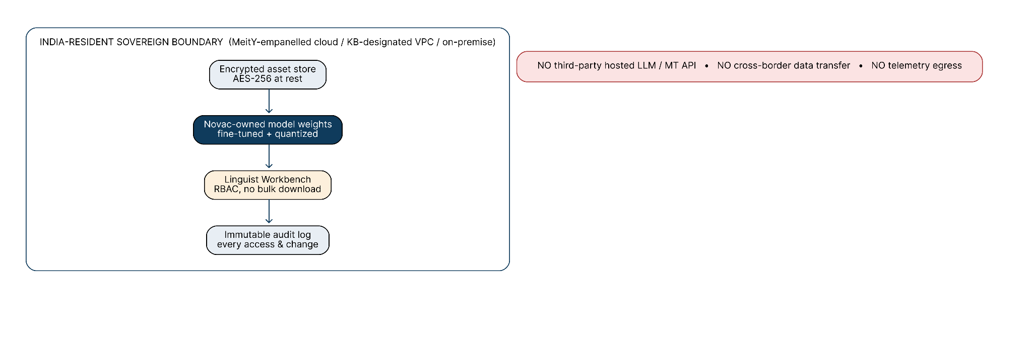
Figure 7 — Sovereign Data Boundary: all processing, storage and human review remain inside India

7A. Delivery Organisation & Governance
A single accountable Project Manager owns the KB relationship. Beneath that, the team is organised by language rather than by task, so that one language lead is answerable end-to-end for accuracy, voice quality and schedule in their language.
Role | Responsibility | Coverage
Project Manager | Single point of contact for KB; monthly plan, SLA ownership, escalation | 1 (full-time)
Delivery / Production Manager | Batch scheduling, capacity allocation, CBP submissions | 1
Language Leads | Per-language accuracy and sign-off; glossary ownership | 1 per active language
Linguist Post-Editors | Contextual post-editing in the workbench | Pooled, scaled to monthly hours
Voice QA / Voice Artists | Pronunciation, prosody and naturalness validation | Per language
QA Lead | Gate enforcement, certification packs, defect closure | 1
AI / Platform Engineering | Model fine-tuning, quantization, pipeline operations | Novac Immerz core team
Security & Compliance Officer | Data residency, access control, audit | 1

Governance cadence: weekly delivery status to KB, monthly milestone review with the Verification Agency, and a quarterly quality and glossary review.

7B. Key Risks and How the Platform Absorbs Them
Risk | Impact if unmanaged | Mitigation built into the MigotoAI Translation Engine
Indic speech expands 15–30% over English | Breach of the 20% output-duration rule | Duration-constrained TTS with pause redistribution; automatic length-ratio guard flags any segment before submission
Terminology drifts across 61 courses | Verification Agency raises consistency defects | Central versioned glossary + Translation Memory enforced at inference across every course and language
Peak months at 125 hours (2.5x month 1) | Miss of the 95% monthly delivery SLA | Quantized models enable 11 parallel language pipelines; capacity sized at ~1.4x peak; standby linguist bench
Low-resource languages (Bodo, Santhali, Dogri) | Poor machine output, slow linguist sourcing | Two-tier model strategy with pivot translation and LoRA adapters; higher human post-editing weighting; pre-empanelled linguists
Late or incomplete source assets from KB | SLA clock runs against the vendor unfairly | T0 formally stamped at intake; automated completeness report issued to KB the same day
Correction round-trips collide with next batch | Cascading delay across months | Segment-level re-run (no full-course reprocessing) plus reserved correction capacity in every sprint
Data confidentiality of government content | Compliance breach | Closed India-resident boundary, no external AI APIs, RBAC, immutable audit trail

8. Proof of Concept Approach
For the assigned POC course in Hindi and Punjabi, Novac will execute the full production pipeline described above — not a demonstration shortcut — and will submit, alongside the translated course: the exclusion manifest, the applied glossary and DNT registry, the QE and terminology-compliance report, the duration-ratio report, the named linguist certification, and a model-provenance statement identifying the fine-tuned and quantized model versions used. If invited to present, Novac will demonstrate the platform live, including glossary enforcement, DNT protection, post-editing workbench, duration-constrained TTS and the SLA command centre.

9. Summary Position
Novac brings a proprietary, India-sovereign, production-grade localisation platform rather than an assembled toolchain; Novac-owned fine-tuned and quantized models rather than dependence on external APIs; deterministic terminology governance rather than best-effort consistency; and an instrumented delivery command centre that treats the ToR’s SLAs as engineering constraints designed into the system. This is what allows Novac to commit to 1,105 output hours across 11+ Indian languages at 98% linguistic accuracy within the contract period.

